khaneilcampbell.com Portfolio Site
Project Overview · web-01
Project ID | Category | Status | Last verified
web-01 | Web & Cloud Infrastructure | Active Development (live; redesigned 2026-10-23) | 2026-10-26
Source | Location
GitHub repository | khancam15/khaneilcampbell.com
Live site | khaneilcampbell.com
Local folder | Local clone on your Mac (34 commits behind main)
Related Claude conversation | None accessible
How to read the labels. [Verified] read in the repository, its history or your local folder. [Inferred] my reasoning. [Recommended] a suggestion.
Contents. Project Reorientation · 1 Executive Summary · 2 Problem Statement · 3 Objectives · 4 Current Status · 5 Technology Stack · 6 Architecture · 7 Workflow · 8 Key Decisions · 9 Challenges and Solutions · 10 Limitations · 11 Next Steps · 12 Career Relevance · 13 Last Updated

Project Reorientation
A five-minute read to pick the project back up.
Where you left off. [Verified] On 2026-10-23 and 24 you shipped the “Atelier” redesign in 31 commits: new type and brass palette, interactive architecture diagrams for both case studies, rewritten Home, About, Work and Contact copy, and NYC Health + Hospitals added to Home and About. A docs/portfolio-review branch (3 commits, 2026-10-24 to 25) clarifies that _headers is not enforced on GitHub Pages and updates repository links. It is not merged.
What the site is. [Verified] A static, hand-written HTML portfolio served by GitHub Pages: Home, About, Work (two full case studies and two in-progress case files), Contact, four credential pages, Privacy and a 404 page. No build step, no cookies, no analytics, no third-party requests.
How it is built. [Verified] One stylesheet, one first-party enhancement script, self-hosted fonts, and a strict Content Security Policy in a meta tag on every page. A GitHub Actions workflow checks the security tags on every push and pull request; two local audit scripts check more.
What you learned. Content Security Policy, accessible markup and contrast, SEO metadata and JSON-LD, progressive enhancement, cache-busting, and running a site through pull requests.
What remains unresolved.
- [Verified] docs/PORTFOLIO-PLAN.md lists decisions D1 to D13 still open, including whether to name Benjaire (D1) and whether to keep the in-progress case files (D9). Its “Production status” section still describes the previous design.
- [Verified] Three old branches sit on a rewritten history and share only the first commit with main.
- [Verified] The docs branch is unmerged; your local clone stops at 2026-10-12.
What to work on next. Merge the docs branch, decide D1 and D9, update the plan’s status section, and add the writing section the README calls “the highest-value next step.”
Explain it without AI in one breath. “It’s a hand-built static portfolio on GitHub Pages with a strict content security policy, no third-party requests, accessible design, and automated security checks on every pull request.”

1. Executive Summary
[Verified] Your public portfolio, positioned around AI solutions, automation, cybersecurity and enterprise systems. It hosts the case studies for the commerce pipeline (ai-01) and the Splunk lab (sec-01).

2. Problem Statement
[Inferred] You needed one credible place that shows your work with evidence, for recruiters and clients, without trackers or claims you cannot support. [Verified] The plan’s “Verified and unverified content” table shows that evidence standard in practice.

3. Project Objectives
[Verified] From docs/VISION.md and the plan: present the work, background, credentials and direction; every claim backed by a source; fast, private and accessible.

4. Current Development Status
Area | State | Evidence
Live site, Atelier design | Live | README “Current production”; 25 commits on 2026-10-23
Case studies (ai-01, sec-01) | Live, with interactive diagrams | PR #34
Phishing and access-control case files | Published as in progress | Decision D9 open
Benjaire case study | Not published | Decision D1 open
Local audits | Passing | [Verified] I ran both on 2026-10-26: 14 pages, 0 failures; 133 checks passed
Docs branch | Unmerged | 3 commits
Local copy | Out of date | 70620ef, 34 commits behind

5. Technology Stack
Technology | Role
HTML and CSS | Every page, hand-written; assets/site.css is the design system
JavaScript (assets/site.js) | Optional enhancement: reveals, mobile menu, diagram inspector
Instrument Serif and Sans | Self-hosted fonts
GitHub Pages | Hosting from main
Cloudflare | Domain registrar, DNS, Email Routing
GitHub Actions | security-check.yml
Python and Bash | site_audit.py, site_inventory.py, security-check.sh
JSON-LD | Structured data on every page except 404

6. System Architecture
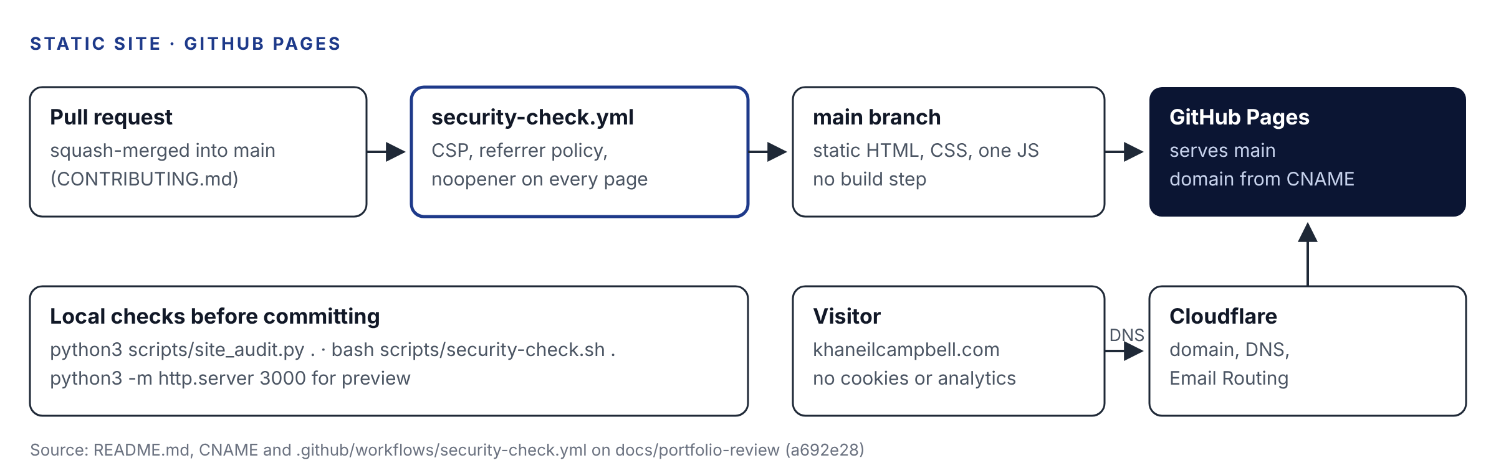
Hosting and change flow, drawn from README.md and the workflow

7. Workflow Explanation
- Edit HTML or CSS locally; preview with python3 -m http.server 3000.
- Run site_audit.py and security-check.sh.
- If CSS or JS changed, recompute the content hash in the asset URLs.
- Open a pull request; the security workflow runs; squash-merge to main.
- GitHub Pages publishes; Cloudflare DNS points the domain at it.

8. Key Engineering Decisions
Decision | Why (as documented) | Label
No build step, static HTML | Simple hosting; Astro migration considered but not started | Verified
CSP default-src 'none', script-src 'self', no inline code | No third-party origins, no network calls | Verified
Every page works without JavaScript | Script is enhancement only | Verified
Self-hosted fonts | No requests to other origins | Verified
Content hash on CSS and JS URLs | Stops fresh HTML pairing with a stale file in cache | Verified
Public résumé without phone number | Decision D6, 2026-10-14 | Verified
Service desk metrics removed | Owner decision: they did not fit the positioning | Verified
Claims must be backed by evidence | Plan section 11 | Verified

9. Challenges and Solutions
Challenge | Solution | Evidence
Many design directions before settling | Mist and glass (2026-10-14), then Atelier (2026-10-23) | Commit history
Mobile diagrams and grids broke | Fixed | 2026-10-07 commits
Contrast failures | Fixed in final audit | 8dff0ec
Stale CSS served with new HTML | Versioned asset URLs | 0956993
_headers file does nothing on GitHub Pages | Documented on the docs branch; CSP meta tag is what is enforced | 63d3ce7
Overstated claims about the pipeline | “Correct pipeline claims” | PR #6

10. Current Limitations
[Verified] From the README and plan: GitHub Pages cannot send real security headers, so policies that need headers (for example frame-ancestors, HSTS settings you control) are not enforced; there is no writing section, so the site ranks mainly on your name; the CI checks three tags, while fuller audits run only locally.

11. Next Development Steps
- [Recommended] Merge docs/portfolio-review.
- [Recommended] Decide D1 (Benjaire) and D9 (in-progress case files).
- [Recommended] Update the plan’s “Production status” to the Atelier design.
- [Recommended] Delete the three stale branches after a last look.
- [Recommended] Add site_audit.py to CI.
- [Recommended] Start the writing section.
- [Recommended] Pull main into your local clone.

12. Career Relevance
Role focus | What this project shows
Web and security | CSP design, secure defaults, privacy by design
AI Solutions | A documented, honest record of building with Claude
Communication | Evidence-backed copy and case studies

13. Last Updated
Field | Value
Last verified | 2026-10-26
Verified against | main at b6283c4 (2026-10-24) and docs/portfolio-review at a692e28 (2026-10-25)
Also read | Local folder git metadata; ran both audit scripts
Prepared by | Claude, for review by Khaneil Campbell

